1. **Problem definition and description**

The main purpose of the project is to visualize data from two different sources, each in an appropriate form. One dataset is the daily temperatures of Daejeon, given the values in degrees Celsius including minimum and maximum values by date. The other is the information of weather stations in Korea, given the ID and coordinates of each station.

The first dataset was chosen to be plotted in deflected line graphs as it could be analyzed as a time-series. Plus, the second dataset was chosen to be plotted as a geographical 3D bar graph on Google Earth.

# DailyTemperatureDaejeon.csv: plot by date

daily_temp=go.Scatter(x=date_series, y=daejeon['Daily temperature'], mode='lines', name='Daily', line=dict(color='#0C2141'))

maximum_temp=go.Scatter(x=date_series, y=daejeon['Maximum'],mode='lines',opacity =.8,name='Highest', line=dict(color='#EF5350'))

minimum_temp=go.Scatter(x=date_series,y=daejeon['Minimum'],mode='lines',opacity=.8,name='Lowest',line =dict(color = '#2068B3'))

# DailyTemperatureStation.csv: 3D Bar Plot

# Categorize by Altitude to put different colours

station['Alt_range']=pd.qcut(station['Altitude (m)'], q = 6)

# Draw Top Circle of the Cylinder Bar Plot

top=Polycircle(latitude=latitude,longitude=longitude,radius=5000,number_of_vertices=36)

# Draw Wall of the Cylinder Bar Plot

bar_wall=[tuple(a_point),tuple(a_point_with_height),tuple(b_point_with_height),tuple(b_point), tuple(a_point)]

wall=bar.newpolygon(altitudemode = 'absolute', outerboundaryis=tuple(bar_wall))

1. **Core code**
2. **Results and plots**

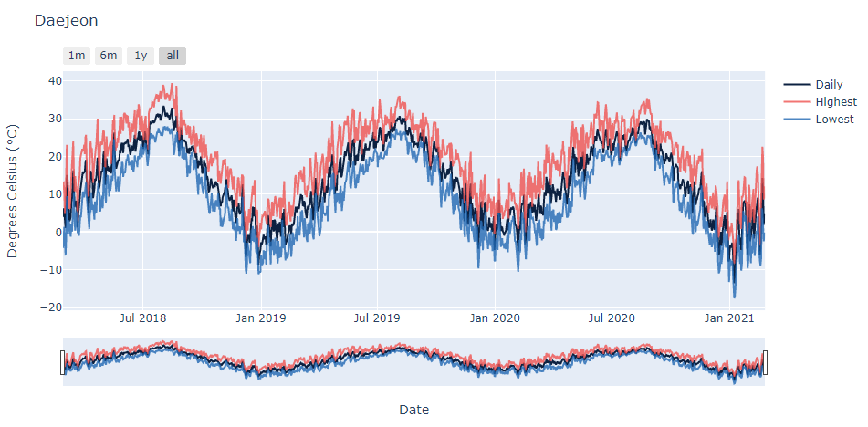

**Figure 1. Daily Temperatures of Daejeon**

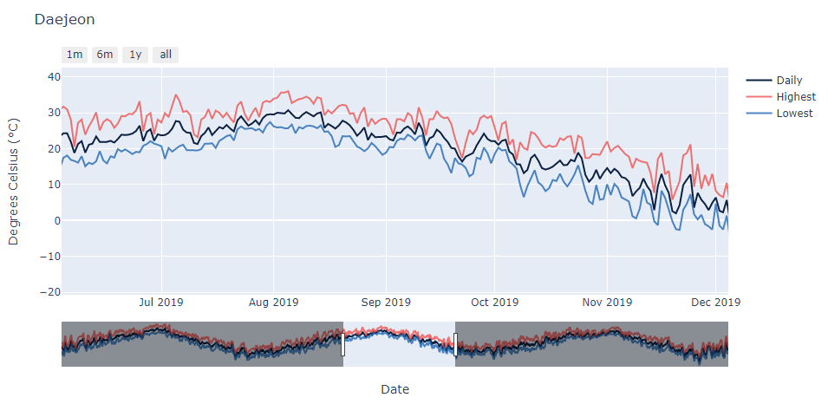

**Figure 2. Graph in 1-Month (Button Activated)**

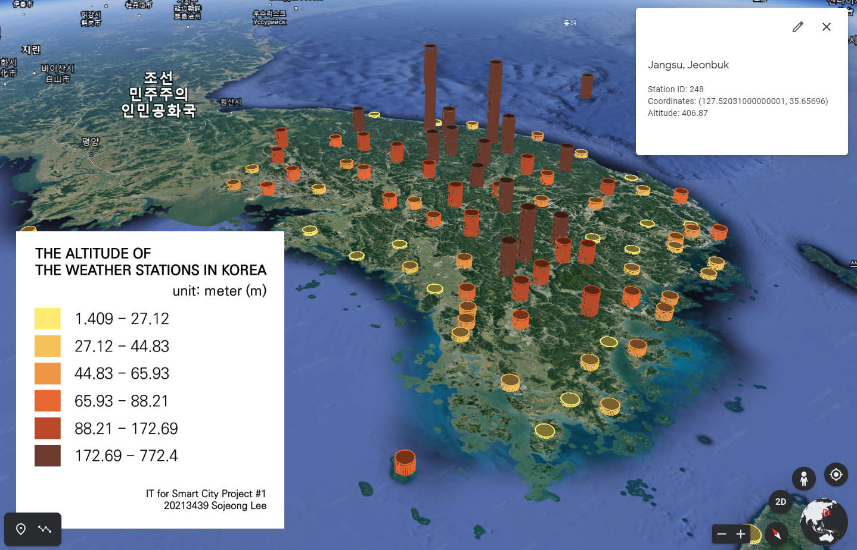

**Figure 3. Daily Temperature Stations (The Altitude of the Weather Stations in Korea)**

1. **Discussion**

As we can see in Figures 1 and 2, line graphs by times effectively show the temperature change as a whole. To expand it more clearly, buttons were created as 1 month, 6 months and 1-year intervals. In Figure 3, the altitude of the weather stations in Korea could be compared easily at a glance by the height of the graph and its colors based on the categorization.

1. **Refernces**

John Hunter, Darren Dale, Eric Firing, Michael Droettboom and the Matplotlib development team, 2002-2021. *Matplotlib 3.3.4 Documentation*. Available online: https://matplotlib.org/stable/contents.html (accessed on 7 March 2021).

Adam Matan, 2014. *Polycircles KML circles*. Available online: https://polycircles.readthedocs.io/en/latest/kmls.  
html (accessed on 8 March 2021).

Bjørn Sandvik, 2008. *Thematic Mapping Engine*. Institute of Geography - School of GeoSciences - University of Edinburgh. Available online: http://themati  
cmapping.org (accessed on 8 March 2021).

Google Developers, 2020. *Keyhole Markup Language*. Available online: https://developers.google.com/kml/doc  
umentation/kmlreference (accessed on 9 March 2021).

Kyle Lancaster, Patrick Eisoldt, 2011-2019. *Simplekml 1.3.5 documentation*. Available online: https://simplekml.  
readthedocs.io/en/latest/index.html (accessed on 9 march 2021).